Kodu Game Lab

NASA/JPL expansion Design Document

# Overview

The expansion pack including NASA/JPL features would include features to allow students and teachers to try their hand at planet exploration, along with guide a rover through different obstacles and experiences.

The overall goal is to extend Kodu’s feature to include new characters, new programming tiles and new curriculum. Teachers would be able to use this as a part of class, NASA would create different opportunities to engage children, and kids would learn to create new experiences with new characters and actions..

# Schedule

Schedule is subject to change, but overall goal is to be completed by July 15th, in order to meet objectives of having content available for rover landing in August.

**Development Schedule:**

|  |  |  |
| --- | --- | --- |
| Milestone | End | Goal |
| Pre-Production | June 15th | Review design of levels and curriculum;  review development and engineering tasks;  general prototype available. |
| Code/Content complete | June 29th | All feature work completed;  All levels built and working in game.  Audio assets, text included in game |
| Final release | July 12th | All bugs fixed, which were found as a part Content Complete phase;  Build is created and signed per internal processes. |

**Curriculum Schedule:**

Curriculum schedule would follow in a similar patter, with more frequent touch points. Goal would be to have curriculum written by June 29th, in preparation for final release.

# Development Features

Adding functionality into the game is the primary goal of this project. Here are the required development features we are looking to add.

Rover Object:

The Rover is a 6 wheeled vehicle designed to cover a variety of territory, turn itself over should it fall, and carries a wide assortment of technical measuring instruments. In Kodu, we would need to add this object, as one doesn’t exist today. Requirements for this object would be:

1. It can resemble “Curiosity”, but should also have “Kodu-esque” features.
2. Its “icon” would also represent the rover, and clearly identified as “Rover”.
3. It would have 6 legs (similar to the design of Curiosity) and a Mast for the cameras.
4. Additionally, having a ‘probe’ to expand and ‘inspect’ would be part of this rover.
5. When placing the object in the world, and at a “Rest State”, the object would have small movements, similar to other objects, to show ‘character’.
6. Rover would inherit all general settings, with a couple of call outs:
   1. Multipliers would be modified to fit “feel” of rover.
   2. “Hit points” would be raised; Ultimately, want max hit points.
   3. “Stay above water” would be on.

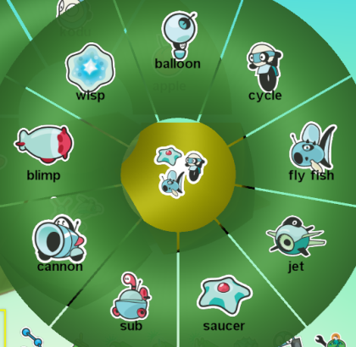

Figure Rover icon added here

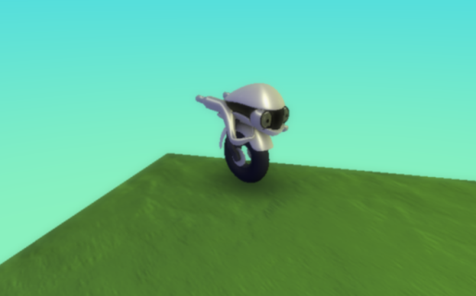

Figure Rover "at rest"; has idling mode

Rover Tile Commands

When the rover lands, it will have a highly sophisticated suite of tools onboard. As a part of recreating content relevant to planetary exploration, we also want to expose tiles which can be used in the game. Here are a list of potential ideas: Note that we would need to review the language of the tiles and how they are used to ensure they are grammatically aligned with existing Kode:

1. **“inspect”** : “inspect” would stop at an object and extend a probe. The return values depend on what the programmer implements. (WHEN inspect blue rock DO return blue points 10). The “inspect” tile would have the following function on a rover:
   1. Stops at a particular object
   2. Positions and extends probe (animation)
   3. Retracts probe, and continues executing kode in program.
   4. Takes less time than Beam
   5. Worth more points than Beam
2. “**beam**” : “Beam” would send a pulsing beam from the Rover to the object. The object would, when hit with beam, emit a small amount of smoke, similar to the smoke in the factory. This would need to be built such that
   1. Rover stops at object:
   2. Rover calls command: “When bump Rock A DO beam <it>
   3. Rock then emits smoke, signifying it has been “beamed”.
   4. Takes less time than Inspect
   5. Worth less points than Inspect

Note: To differentiate original rock, and “new” rock, only the new rock exerts smoke when hit by the beam. If smoke is detected, we can then add this into the ‘scores’ table and signify special rock was detected.

Alternatively we could remove the rock from play.

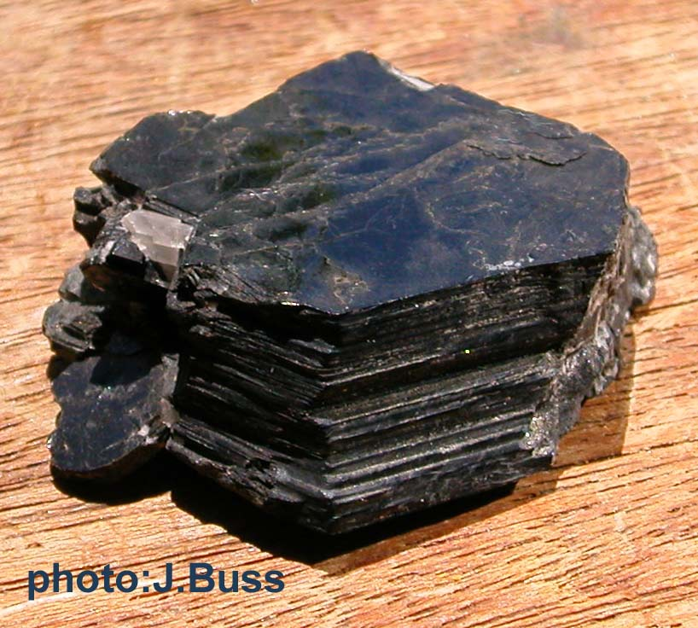[[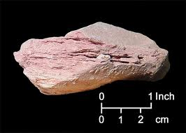](http://www.google.com/imgres?hl=en&client=firefox-a&hs=QTL&sa=X&rls=org.mozilla:en-US:official&biw=1556&bih=721&tbm=isch&prmd=imvns&tbnid=D3czvOJvmLdHEM:&imgrefurl=http://www.dep.state.fl.us/geology/geologictopics/rocks/common_clay.htm&docid=fnoU_57jEXfkEM&imgurl=http://www.dep.state.fl.us/geology/geologictopics/rocks/common_clay.jpg&w=504&h=360&ei=BZfPT6OCAYjO2wW02tjIDA&zoom=1&iact=hc&vpx=200&vpy=174&dur=688&hovh=185&hovw=255&tx=118&ty=65&sig=104935925278239038653&page=1&tbnh=163&tbnw=209&start=0&ndsp=18&ved=1t:429,r:0,s:0,i:74)](http://www.google.com/imgres?hl=en&client=firefox-a&hs=QTL&sa=X&rls=org.mozilla:en-US:official&biw=1556&bih=721&tbm=isch&prmd=imvns&tbnid=D3czvOJvmLdHEM:&imgrefurl=http://www.dep.state.fl.us/geology/geologictopics/rocks/common_clay.htm&docid=fnoU_57jEXfkEM&imgurl=http://www.dep.state.fl.us/geology/geologictopics/rocks/common_clay.jpg&w=504&h=360&ei=BZfPT6OCAYjO2wW02tjIDA&zoom=1&iact=hc&vpx=200&vpy=174&dur=688&hovh=185&hovw=255&tx=118&ty=65&sig=104935925278239038653&page=1&tbnh=163&tbnw=209&start=0&ndsp=18&ved=1t:429,r:0,s:0,i:74)

Also for rocks—if you want to just change a size and have little round ones, that’s authentic to Mars as well, and indicates hematite, a mineral that forms in water. If the player is seeing those, they have one clue that the area could have been a habitat. Looking for sedimentary rocks there to see if the area also has organics would be interesting—some areas could have it, some not.

[[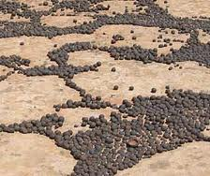](http://www.google.com/imgres?hl=en&client=firefox-a&rls=org.mozilla:en-US:official&biw=1556&bih=721&tbm=isch&tbnid=wvscNkapwcNYpM:&imgrefurl=http://phoenix.lpl.arizona.edu/mars153.php&docid=GJPd4IFgZYggmM&imgurl=http://phoenix.lpl.arizona.edu/images/picHematiteUtah.jpg&w=280&h=236&ei=jZrPT9mDMYqj2QXKsa2lDQ&zoom=1&iact=hc&vpx=952&vpy=168&dur=682&hovh=188&hovw=224&tx=114&ty=117&sig=104935925278239038653&page=1&tbnh=166&tbnw=197&start=0&ndsp=21&ved=1t:429,r:4,s:0,i:80)](http://www.google.com/imgres?hl=en&client=firefox-a&rls=org.mozilla:en-US:official&biw=1556&bih=721&tbm=isch&tbnid=wvscNkapwcNYpM:&imgrefurl=http://phoenix.lpl.arizona.edu/mars153.php&docid=GJPd4IFgZYggmM&imgurl=http://phoenix.lpl.arizona.edu/images/picHematiteUtah.jpg&w=280&h=236&ei=jZrPT9mDMYqj2QXKsa2lDQ&zoom=1&iact=hc&vpx=952&vpy=168&dur=682&hovh=188&hovw=224&tx=114&ty=117&sig=104935925278239038653&page=1&tbnh=166&tbnw=197&start=0&ndsp=21&ved=1t:429,r:4,s:0,i:80)

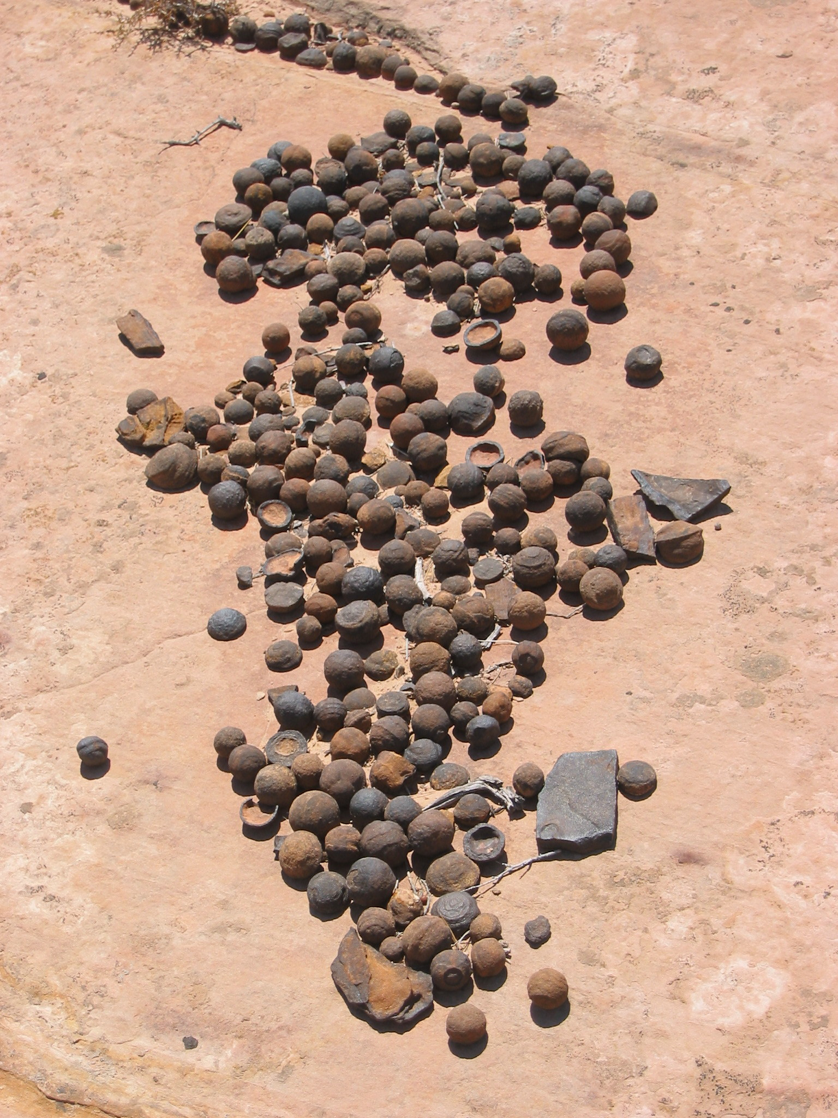

In terms of lava rocks, they primarily look like this (black and porous—that also can be done as a skin/art design.

[[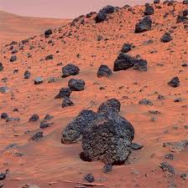](http://www.google.com/imgres?hl=en&client=firefox-a&rls=org.mozilla:en-US:official&biw=1556&bih=721&tbm=isch&tbnid=71354uTx_LsP9M:&imgrefurl=http://xfinity.comcast.net/slideshow/news-marsrover/5/&docid=DGZaahLp4Ayl6M&imgurl=http://por-img.cimcontent.net/api/assets/bin-200912/da462614de6b95f55b0e97161da1a1cb.jpg&w=399&h=400&ei=s5vPT_6UM9Cl2AXhzJCwDA&zoom=1&iact=hc&vpx=191&vpy=323&dur=135&hovh=225&hovw=224&tx=88&ty=101&sig=104935925278239038653&page=1&tbnh=165&tbnw=165&start=0&ndsp=18&ved=1t:429,r:6,s:0,i:85)](http://www.google.com/imgres?hl=en&client=firefox-a&rls=org.mozilla:en-US:official&biw=1556&bih=721&tbm=isch&tbnid=71354uTx_LsP9M:&imgrefurl=http://xfinity.comcast.net/slideshow/news-marsrover/5/&docid=DGZaahLp4Ayl6M&imgurl=http://por-img.cimcontent.net/api/assets/bin-200912/da462614de6b95f55b0e97161da1a1cb.jpg&w=399&h=400&ei=s5vPT_6UM9Cl2AXhzJCwDA&zoom=1&iact=hc&vpx=191&vpy=323&dur=135&hovh=225&hovw=224&tx=88&ty=101&sig=104935925278239038653&page=1&tbnh=165&tbnw=165&start=0&ndsp=18&ved=1t:429,r:6,s:0,i:85)

[[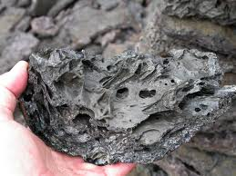](http://www.google.com/imgres?hl=en&client=firefox-a&rls=org.mozilla:en-US:official&biw=1556&bih=721&tbm=isch&tbnid=7D6OwH_wDVkRVM:&imgrefurl=http://meteorites.wustl.edu/id/lavarocks.htm&docid=0JFAmLorOfgS2M&imgurl=http://meteorites.wustl.edu/id/basalt_0885l.jpg&w=1200&h=900&ei=s5vPT_6UM9Cl2AXhzJCwDA&zoom=1&iact=hc&vpx=717&vpy=24&dur=1708&hovh=194&hovw=259&tx=103&ty=84&sig=104935925278239038653&page=1&tbnh=168&tbnw=241&start=0&ndsp=18&ved=1t:429,r:14,s:0,i:102)](http://www.google.com/imgres?hl=en&client=firefox-a&rls=org.mozilla:en-US:official&biw=1556&bih=721&tbm=isch&tbnid=7D6OwH_wDVkRVM:&imgrefurl=http://meteorites.wustl.edu/id/lavarocks.htm&docid=0JFAmLorOfgS2M&imgurl=http://meteorites.wustl.edu/id/basalt_0885l.jpg&w=1200&h=900&ei=s5vPT_6UM9Cl2AXhzJCwDA&zoom=1&iact=hc&vpx=717&vpy=24&dur=1708&hovh=194&hovw=259&tx=103&ty=84&sig=104935925278239038653&page=1&tbnh=168&tbnw=241&start=0&ndsp=18&ved=1t:429,r:14,s:0,i:102)

Some can have olive, so one texture/skin could also be black and olive:

[[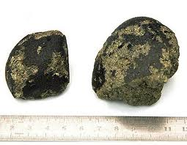](http://www.google.com/imgres?hl=en&client=firefox-a&rls=org.mozilla:en-US:official&biw=1556&bih=721&tbm=isch&tbnid=h63HE46gKNHnzM:&imgrefurl=http://www.foxnews.com/story/0,2933,313443,00.html&docid=vRgSuMi0LcpL3M&imgurl=http://a57.foxnews.com/images/326779/450/350/0_22_meteorite_mars.jpg&w=450&h=350&ei=s5vPT_6UM9Cl2AXhzJCwDA&zoom=1&iact=hc&vpx=834&vpy=410&dur=936&hovh=198&hovw=255&tx=197&ty=112&sig=104935925278239038653&page=2&tbnh=153&tbnw=197&start=18&ndsp=25&ved=1t:429,r:3,s:18,i:119)](http://www.google.com/imgres?hl=en&client=firefox-a&rls=org.mozilla:en-US:official&biw=1556&bih=721&tbm=isch&tbnid=h63HE46gKNHnzM:&imgrefurl=http://www.foxnews.com/story/0,2933,313443,00.html&docid=vRgSuMi0LcpL3M&imgurl=http://a57.foxnews.com/images/326779/450/350/0_22_meteorite_mars.jpg&w=450&h=350&ei=s5vPT_6UM9Cl2AXhzJCwDA&zoom=1&iact=hc&vpx=834&vpy=410&dur=936&hovh=198&hovw=255&tx=197&ty=112&sig=104935925278239038653&page=2&tbnh=153&tbnw=197&start=18&ndsp=25&ved=1t:429,r:3,s:18,i:119)

[[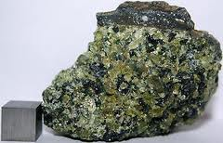](http://www.google.com/imgres?hl=en&client=firefox-a&hs=aUg&sa=X&rls=org.mozilla:en-US:official&biw=1556&bih=721&tbm=isch&prmd=imvns&tbnid=F4yJuyOXGpKmMM:&imgrefurl=http://www.ebay.com/itm/Quality-Xenolith-volcanic-Lava-OLIVINE-Peridot-BOMBS-Kilbourne-Hole-NM-106-8g-/251049728477&docid=mPHHEciwvhYoRM&itg=1&imgurl=http://i.ebayimg.com/00/s/MTAzM1gxNjAw/$(KGrHqRHJEEE94gWt8S1BPf6OhrW5Q~~60_35.JPG&w=300&h=193&ei=UJzPT63kKsOq2gWxrfzoDQ&zoom=1&iact=hc&vpx=677&vpy=222&dur=1717&hovh=154&hovw=240&tx=137&ty=79&sig=104935925278239038653&page=2&tbnh=154&tbnw=221&start=19&ndsp=24&ved=1t:429,r:20,s:19,i:160)](http://www.google.com/imgres?hl=en&client=firefox-a&hs=aUg&sa=X&rls=org.mozilla:en-US:official&biw=1556&bih=721&tbm=isch&prmd=imvns&tbnid=F4yJuyOXGpKmMM:&imgrefurl=http://www.ebay.com/itm/Quality-Xenolith-volcanic-Lava-OLIVINE-Peridot-BOMBS-Kilbourne-Hole-NM-106-8g-/251049728477&docid=mPHHEciwvhYoRM&itg=1&imgurl=http://i.ebayimg.com/00/s/MTAzM1gxNjAw/%2524%28KGrHqRHJEEE94gWt8S1BPf6OhrW5Q%7E%7E60_35.JPG&w=300&h=193&ei=UJzPT63kKsOq2gWxrfzoDQ&zoom=1&iact=hc&vpx=677&vpy=222&dur=1717&hovh=154&hovw=240&tx=137&ty=79&sig=104935925278239038653&page=2&tbnh=154&tbnw=221&start=19&ndsp=24&ved=1t:429,r:20,s:19,i:160)

Not necessarily for this version (though I did like the sample terrain that “faked layers,” but just so you have it, exploration is really about understanding the history of a place through layered terrain, with the layers at the bottom being the oldest. Each layer is often different, reflecting a different climate in the past. We look for rocks that only form in the presence of long-standing water. If we find those minerals in a particular layer, that indicat es a time and place that might have been conducive to life. Some rocks (e.g., phyllosilicates) are better at preserving signs of organics, the chemical building blocks of life. That’s why Curiosity is going to Gale Crater—the mountain in the center has particular layers with phyllosilicates. That’s one of the key places we’re thus heading.

What’s true for layers can apply to individual rocks—students should begin to differentiate between “average rocks” aka lava rocks that don’t form in water and don’t preserve evidence of organics and those that are sedimentary (layered deposits delivered by either wind or water and cemented over time). Not all sedimentary rocks are the ones we want, however. You can only tell so much from what your eyes can see. That’s why we need sensors, that can tell us what chemical elements the rocks are made of. Whether the smoke is colored differently or some other square that pops up (e.g., using the Kodu palette—one can be pink polka dots to mean a certain chemistry, another could be green stripes or whatever) or the glow around the object, just need some way of indicating what is special.

[[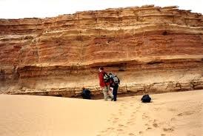](http://www.google.com/imgres?hl=en&client=firefox-a&rls=org.mozilla:en-US:official&biw=1556&bih=721&tbm=isch&tbnid=bCe2L85_kOSFkM:&imgrefurl=http://www.sciencedirect.com/science/article/pii/S0195667108000773&docid=t1ExYyDVKqWNQM&itg=1&imgurl=http://ars.sciencedirect.com/content/image/1-s2.0-S0195667108000773-gr2.jpg&w=660&h=444&ei=dpjPT7eDMYWM2gWB0uSxDA&zoom=1&iact=hc&vpx=185&vpy=361&dur=122138&hovh=184&hovw=274&tx=158&ty=83&sig=104935925278239038653&page=1&tbnh=153&tbnw=204&start=0&ndsp=22&ved=1t:429,r:7,s:0,i:89)](http://www.google.com/imgres?hl=en&client=firefox-a&rls=org.mozilla:en-US:official&biw=1556&bih=721&tbm=isch&tbnid=bCe2L85_kOSFkM:&imgrefurl=http://www.sciencedirect.com/science/article/pii/S0195667108000773&docid=t1ExYyDVKqWNQM&itg=1&imgurl=http://ars.sciencedirect.com/content/image/1-s2.0-S0195667108000773-gr2.jpg&w=660&h=444&ei=dpjPT7eDMYWM2gWB0uSxDA&zoom=1&iact=hc&vpx=185&vpy=361&dur=122138&hovh=184&hovw=274&tx=158&ty=83&sig=104935925278239038653&page=1&tbnh=153&tbnw=204&start=0&ndsp=22&ved=1t:429,r:7,s:0,i:89)

1. “**picture**”: (alternative): Because the rover has the capability of taking pictures, the goal would be to program the rover to take pictures, and capture these as what the rover would see. Currently, Kodu has a way of taking screen shots in game based on the position of the camera, and when player hits “prt/scrn” on keyboard. This functionality would be slightly different, and executed like this:
   1. Rover stops at a position
   2. Code is executed (WHEN next rock DO picture <direction>)
   3. If character is not facing the direction, it animates and faces the direction
   4. View changes briefly, and a small flash occurs, indicating picture was taken.
   5. Player can view pictures located on hard drive (stored on local profile space)
2. “Scan”: When a scan is performed, nearby rocks are changed from unknown to known types. The scan function reveals rock types to the player (see individual level design docs). Students would set up parameters with the rover for when to perform a scan.
   1. Rover stops at position

Code is executed (When Scanning Do asset swap)

Audio

As part of adding in the rover, we would also want to add in sounds to augment the experience. These can be delivered as a part of NASA’s sound bank (if they exist) or can be recreated artificially. These sounds can be added through Kodu’s sound channel. The following are suggestions:

* Rover movement: gears humming
* Rover idle experience: gears alternating between humming and silence
* Rover investigate1: pod-boom extending;
* Rover investigate2: when pod-boom extends and touches object
* Rover beam: small, high powered laser sound (zap)
* Rover beam, result: wisp of smoke sound. Crackle?
* Planetary: Ambient music sound, ethereal,

Rock Object

Currently in Kodu, there is only 1 rock object. While it can be scaled, and there are 11 potential colors associated with that rock, we want to introduce a new rock object type that reacts to certain rover inspections. The idea being that when a rock is identified as “important”, it returns extra information that can be used.

Rock type will be unknown until the player takes action to reveal their type. Specific types of rocks have a greater chance of containing organics and score more points (see individual level design docs)

**Two alternatives have come up during discussions:**

1) When Rock is inspected by rover, the “rock” would change form to reveal a different rock. Example would be to change a rock from type “A” to type “B”, to show interaction. Type b rock would be the second rock available. (it could be labeled “rock 1”, “stone”, or “pebble” to distinguish from “rock”)

2) When rock is inspected by rover, the rock changes type as to what is applied.

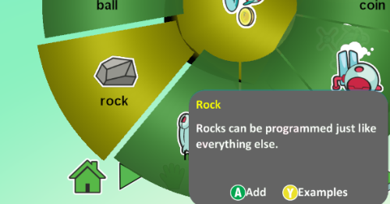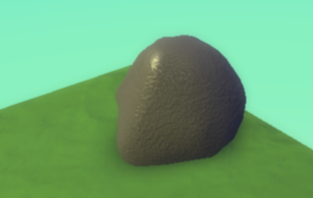Option #1 is probably the best alternative. Adding in new features to program into the rock are out of scope for this project.

Figure 4 Default rock type

Figure 3 Rock Icon in object picker menu

Kodu General Tiles

These engineering updates would be kept to a minimum, but available to all objects in Kodu. Focus would be on integrating these items specifically for game levels listed below:

1. Detect end of Path: Currently, a character can navigate on a select path, but can not detect when it hits the ‘end’ of a path. This tile would allow Kodu to detect when it is at the end of the path, and then take an action. An example of this might be:

WHEN <END OF PATH> <ME> DO express “happiness”

* End of path would be decided when a note is ended, and can not loop or connect to another node.
* 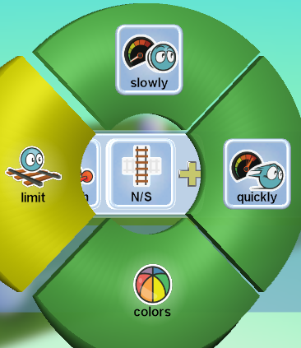At the completion (exit) of a path experience; not when encountering the first edge of a path.
* Must have encountered 1 node first.
* Located as a “limit” item (although could be surfaced earlier).

Levels / Curriculum

The main focus on delivering this content will be to create 3 new, unique levels by the time the Curiosity comes down. These levels should provide:

1. General instructions for students
2. Guidance for teachers on how to implement a lesson plan
3. An element of ‘fun’ which kids can play over again, or experiment and change settings to try new features.

To that end, we are proposing three levels are created. Of these three levels, two will have curriculum associated with the level. If time permits, we will create a fourth level and curriculum.

**Note that these are initial ideas only, and would be finalized by June 15th**

# Level 1: Mars Rover

|  |  |
| --- | --- |
| Audience | K-12th grade |
| Time Length | 90 seconds |
| Level Type | Arcade-like game, focused on getting high score |
| Layout | Side-scrolling |
| Button layout | A: increase speed; B: decrease speed; X: “inspect”; Y: camera |
| Rules | Goal is to earn the most scientific value (points); SV Points are reflected by :   * Each second moving: +1 point * Inspect generic rock: +1 point * Inspect ‘special’ rock: +5 points * Camera shot: +5 points |
| Obstacles | There are a few obstacles:   * Rocks are not easily identifiable; targeting the wrong rock takes time (but still earns points) * Different land types cause rover to speed up/slow down * Going too fast may cause rover to miss rocks (to turn around) or take too much time. * You can only inspect “5” times (to represent the number of drills on the rover). Do you wait to drill * There is a 90 second timer which is continually counting down. |
| Environment |  |
| Curriculum | N/A: meant for a museum, conference, or quick play experience. Code can be opened up to understand how modified tiles work. |

# Level 2: Search & Explore

|  |  |
| --- | --- |
| Audience | K-12th grade |
| Time Length | 1 hour; teach concepts, robotic maneuvering, programming |
| Level Type | Top-down, self-exploratory game. Kids must navigate programmatically. |
| Layout | Top down |
| Button layout | None; because game will be a terrain layout, kids must learn to program character, and return the most amount of points. |
| Rules | Goal is to earn the most scientific value (points); SV Points are reflected by :   * Each second moving: +1 point * Inspect generic rock: +1 point * Inspect ‘special’ rock: +5 points * Camera shot: +5 points * Returning to base, and returning information: 50 points. |
| Obstacles | There are a few obstacles:   * Rocks are not easily identifiable; targeting the wrong rock takes time (but still earns points) * Different land types cause rover to speed up/slow down * Going too fast may cause rover to miss rocks (to turn around) or take too much time. * You can only inspect “5” times (to represent the number of drills on the rover). Do you wait to drill * While there is not a timer, users must learn how to automatically program their robot. There are a few ways to do this:  1. Base on invisible objects which act as reference points. 2. Wander aimlessly (this may be an OK strategy) 3. Incorporate a search-pattern / grid to systematically find objects 4. Consider terrain types, as different terrain types will slow you down. |
| Environment | Kids are given a templatized world. There are rocks (type 1 & 2) scattered throughout. Kids must learn to decide how they will navigate this large world and return the largest number of points possible.  While there are not time limits (unless imposed or needs to be tweaked), the goal would be to find the most amount of points possible. |
| Curriculum | 1. Autonomous robot programming. 2. Consideration of land formations, impact on rover 3. Incorporating detection of rocks, specifically if there is a pattern (color, size, etc) |

# Level 3: Terrain Deployment

|  |  |
| --- | --- |
| Audience | K-12th grade |
| Time Length | 2-4 hours; teach research, design (of terrain), features, events, and presentation skills |
| Level Type | Various; mostly a 3rd person experience, but students may try various angles. |
| Layout | Various |
| Button layout | Incorporate use of “inspect”, “beam”, and “picture” to recreate rover’s experience |
| Rules | Goal is to build an experience on Mars, highlighting the following key elements:   * **Terrain types**: Different materials have different composition, which can be explained as rovers visit this rock types. * **Formations**: camera angles can change depending on location/formation. Players can “jump” to different levels showcasing different formations * **Paths**: What path did previous rovers take? What would be optimal based on landing information? |
| Obstacles | There are a few obstacles:   * Rocks are not easily identifiable; targeting the wrong rock takes time (but still earns points) * Different land types cause rover to speed up/slow down * Going too fast may cause rover to miss rocks (to turn around) or take too much time. * You can only inspect “5” times (to represent the number of drills on the rover). Do you wait to drill * While there is not a timer, users must learn how to automatically program their robot. There are a few ways to do this:  1. Base on invisible objects which act as reference points. 2. Wander aimlessly (this may be an OK strategy) 3. Incorporate a search-pattern / grid to systematically find objects 4. Consider terrain types, as different terrain types will slow you down. |
| Environment | Two potential ways to approach this:   1. Create a world that is finished and polished. Use this as an example of what can be accomplished. Teacher will show this world to students, and students can then example the world, play the world, and record data that’s interesting. 2. Students then would open a “template” world that is flat but with different geography. Their goal is to mimic a sample landing spot, rocks, and map out an optimal experience. 3. Students then walk their teacher/class through that experience and explain why they opted to recreate that landing, highlight interesting features, and how they would navigate through that environment. |
| Curriculum | 1. Review and understanding of an existing landing / mission. 2. Research and design of a new landing site, based on NASA supplied images and information 3. Research into different terrain types, and impact on Rover. 4. Critical thinking and assessment on why they would program rover to execute on a given path. 5. Development of success/failure criteria for a particular mission. |

Additional notes:

* Levels would be shipped as a part of Kodu, as well as available from Community Website.
* Curriculum would be available for download through [www.kodugamelab.com](http://www.kodugamelab.com), and NASA website.
* Game build would need to be rebuilt and re-signed. Microsoft owns building this portion and submitting for download.